Course: IT8145 - DB Programming 2

Class section: 1

# Group Members:

* 201902169 [Hosam Hasanain](https://moodle.polytechnic.bh/moodle/user/view.php?id=9604&course=508)
* 201400908 [Ahmed Alhai](https://moodle.polytechnic.bh/moodle/user/view.php?id=5901&course=508)
* 201900414 Mohamed Saleh
* 202000144 [Sayed Dhiya Algallaf](https://moodle.polytechnic.bh/moodle/user/view.php?id=10371&course=508)

Website URL:

<http://52.148.201.46/~u201900414/MoviesProject/index.php>

# Accounts to be used for testing:

|  |  |  |
| --- | --- | --- |
| **Username** | **Password** | **Account Role Type** |
| User1 | 123 | Viewer |
| Author1 | 123 | Author/Writer |
| Admin1 | 123 | Administrator |

# Extra features used:

* JQuery
* Localization

# Screenshot of ERD:

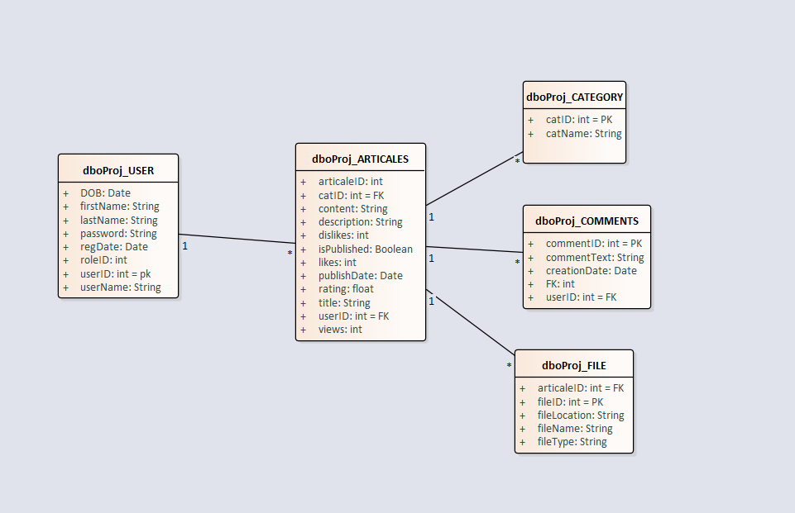

# Test Plan

## Section 1: Creating Tables and Procedure

1. Run the SQL commands inside ProjectSQL.sql file in phpMyAdmin.

## Section 2: Website Registration/Login

To register: head to register page by using the navigation bar.

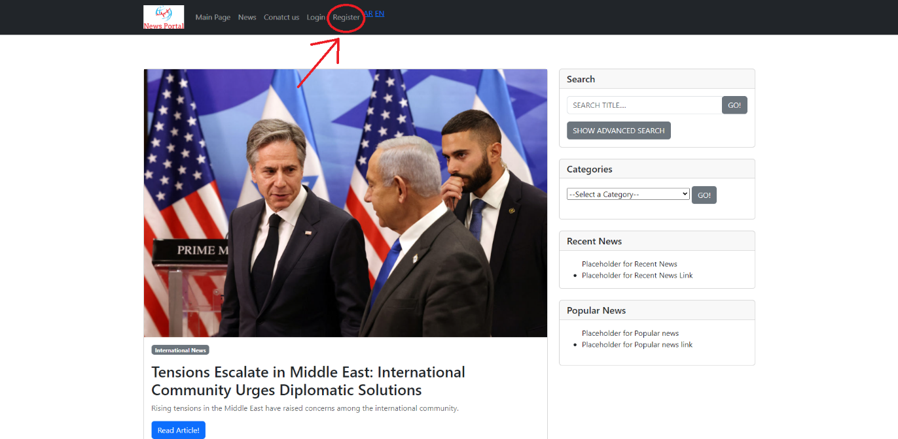

Enter all relative information, once done click on Register button

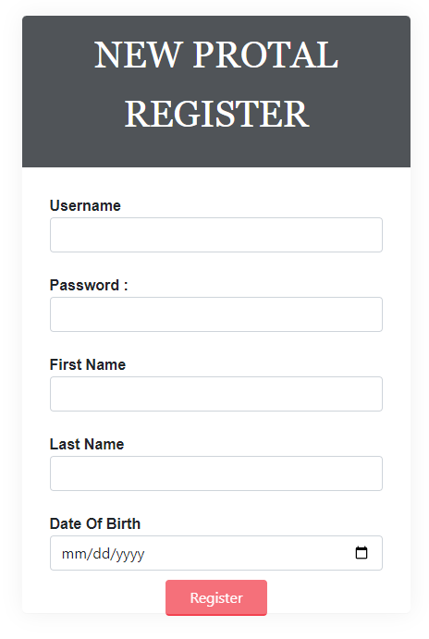

If successful, a success message and a button to head to login page will appear.

New account is registered as a viewer.

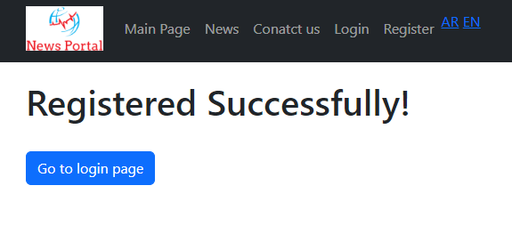

To login: Head to login page from navigation bar.

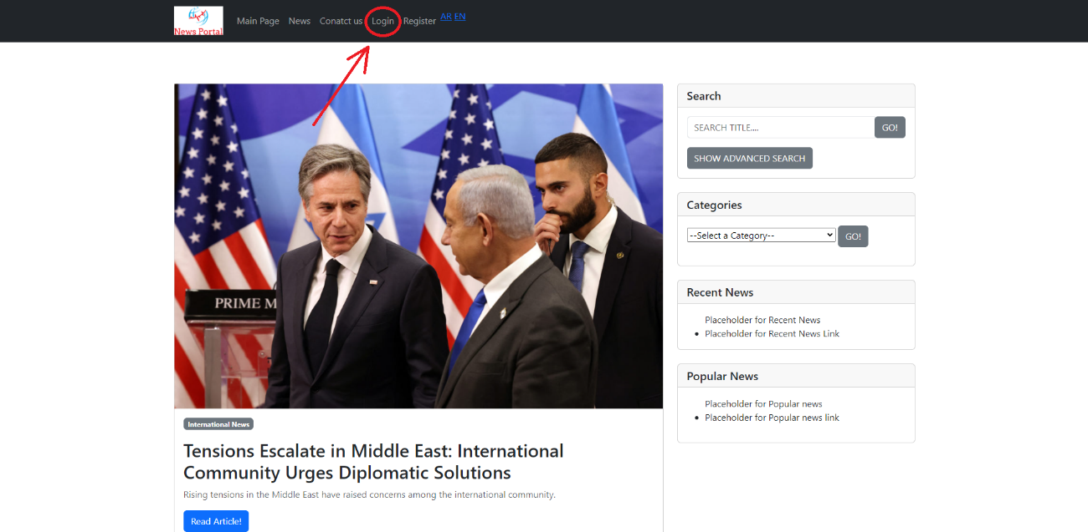

Enter credentials of newly created account or from one of the test accounts

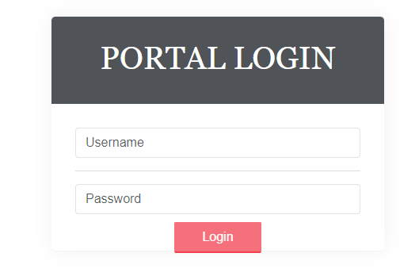

## Section 3: Article Views, Like, & Dislike

The views will increase only if the user has visited the page once and won’t increase if they refresh the page:

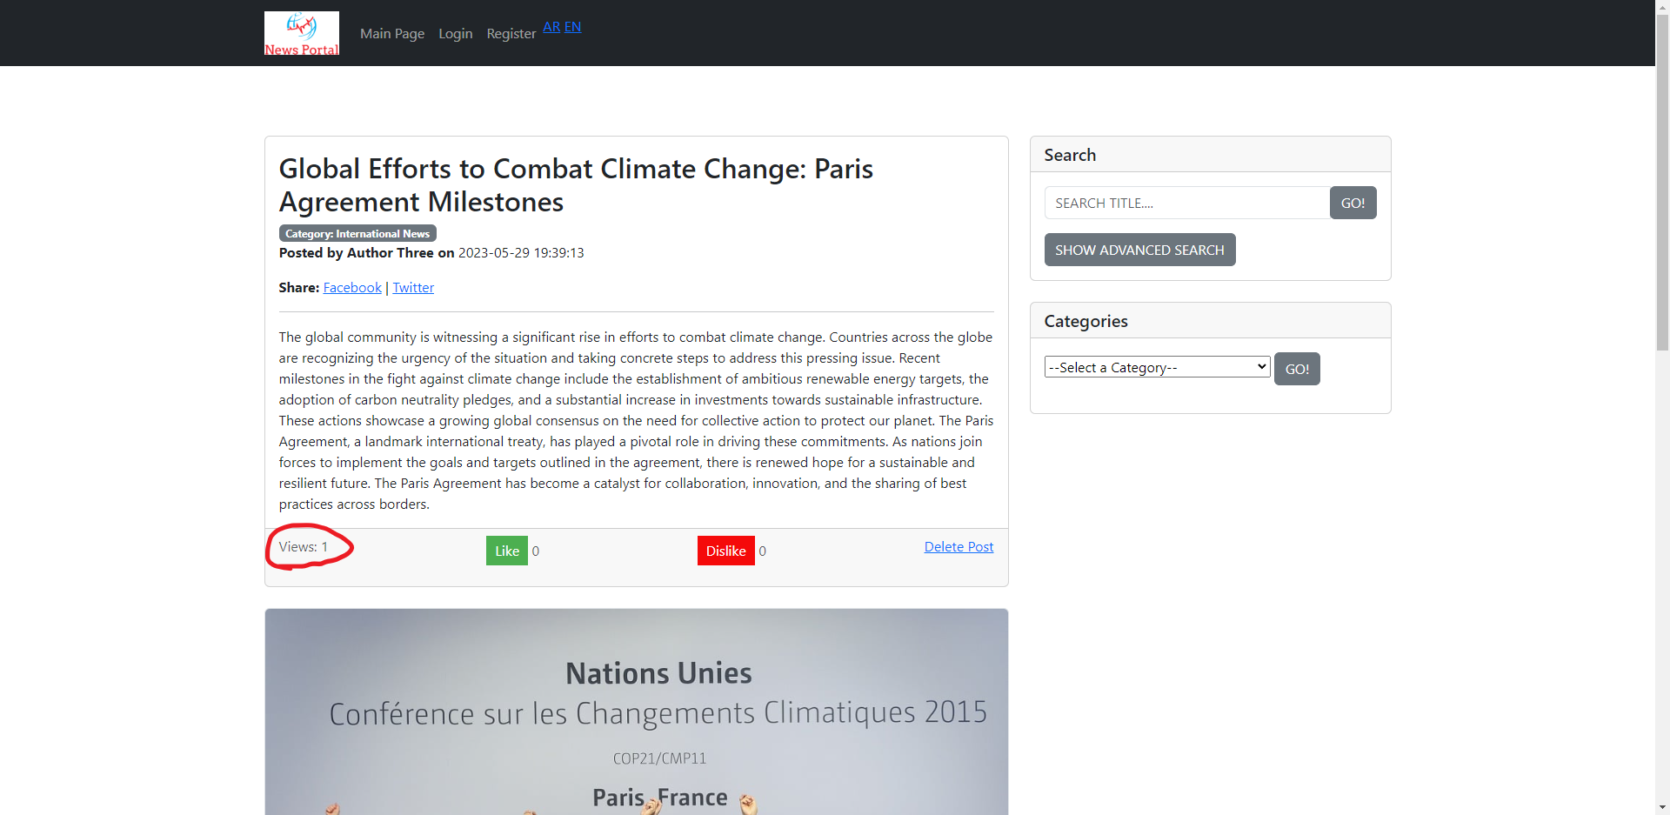

The Like/Dislike feature also allows the user to only increment once they click on one of the button once:

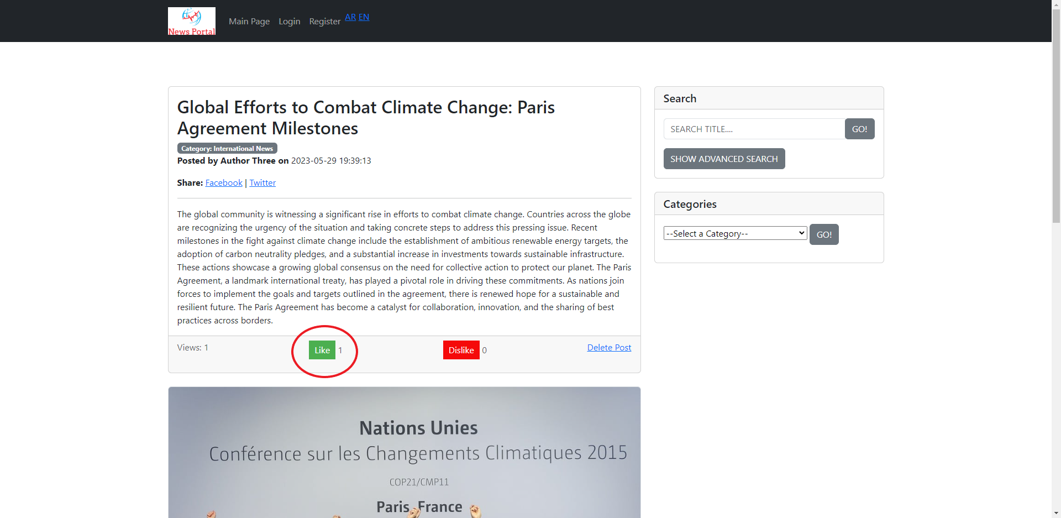

## Section 4: Comments section (Add/Delete)

The non-logged in user is able to see the comment section but they do not have the option to post one unless they sign in:

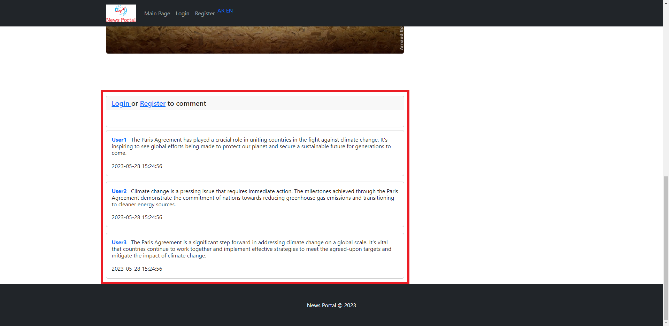

When the user signs in as a viewer or author type they will be able to the post the comment as shown below (Currently logged in as User1 of type Viewer):

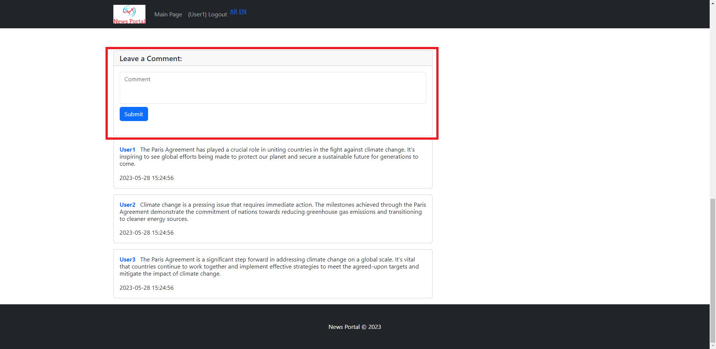

To leave a comment type into the textbox and click on ‘Submit’ button:

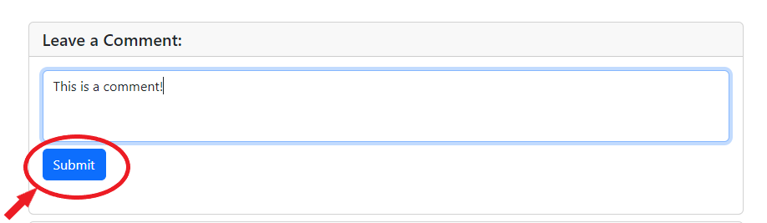

The page will refresh automatically and then the comment will be shown:

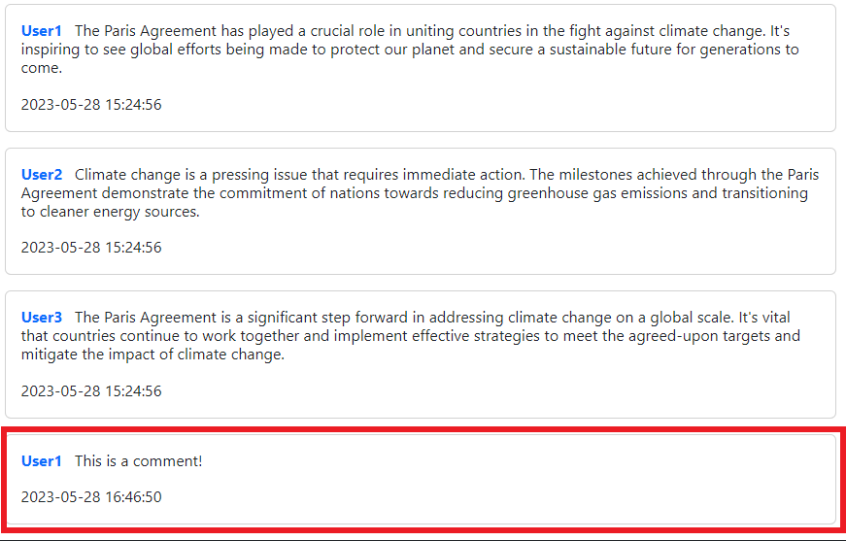

To delete a comment, the user must be logged in as an admin type. The following option on the comments will only be shown to the logged in admin (Logged in as Admin1):

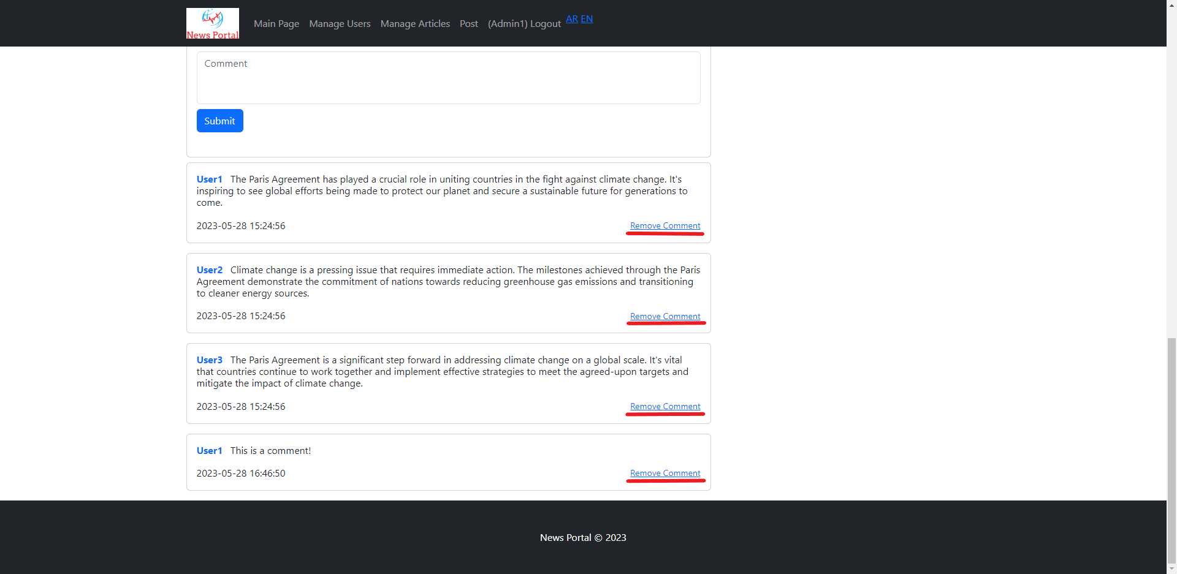

After click on the ‘Remove Comment’ link the following page will be shown, and the admin has to confirm the deletion of the comment by selecting ‘Yes’ and then clicking on ‘Delete’ button:

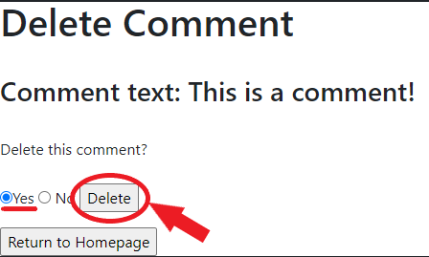

After the deletion of the comment, the following will be shown instead of the original comment:

